Github

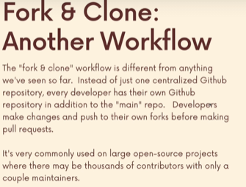
Introducing Forking

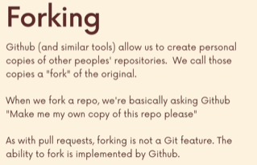





Forking Demonstration
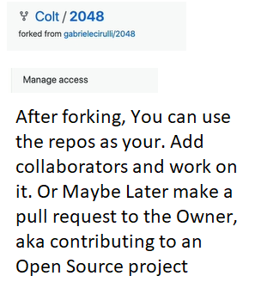

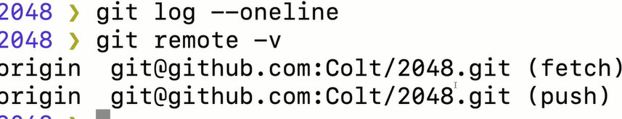

The Fork & Clone Workflow
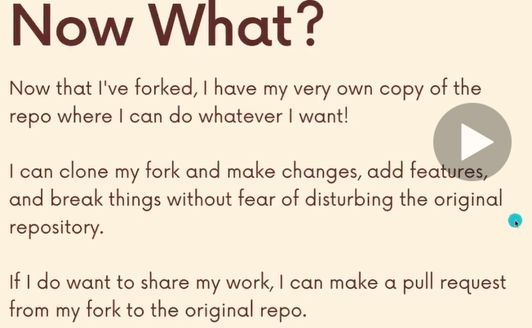

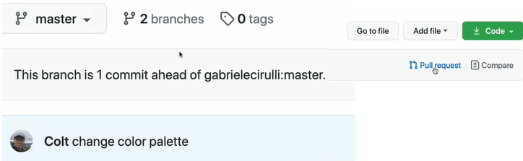
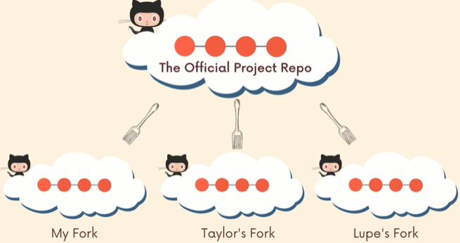

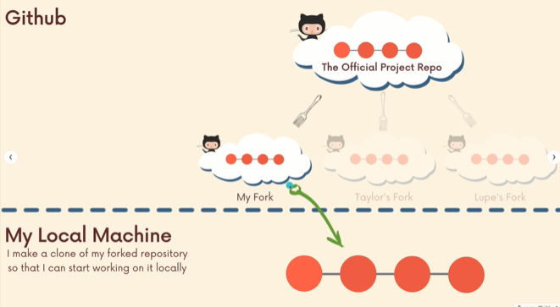

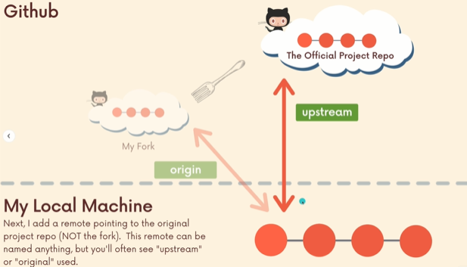

Above, i have an automatic remote setup called origin, just because i clone this repository. Default remote name is origin. So origin refers to my fork. Then i am gonna setup a second remote, it would be anything i called, normally its called upstream. (Conventional name)
It refers to the original repo that we forked.
This allow me a place, where i can do my own changes and push changes into my fork. Also if there is any changes that have been made to the original repository on a large open source project called react. There might be new commits, pull requests, merge daily. I’ll be able to get that down in my machine. So even if i cant push up i can still pull down.
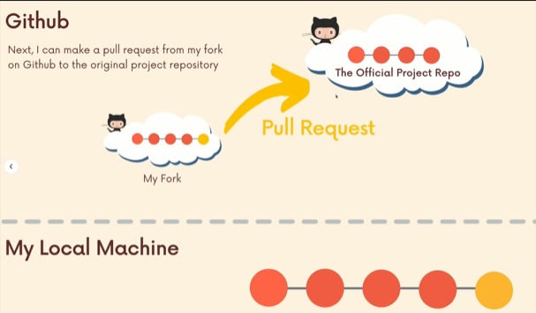

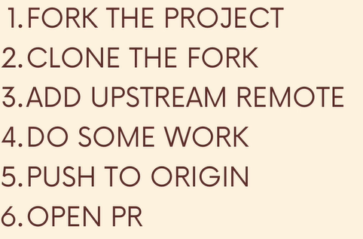

Fork & Clone Workflow Demonstration
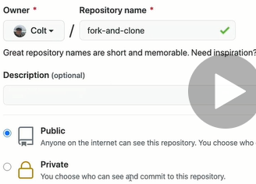
I am not gonna make anybody a collaborator.
Nobody will be able to push to this.

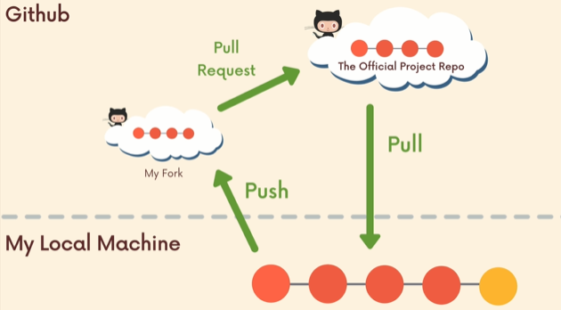

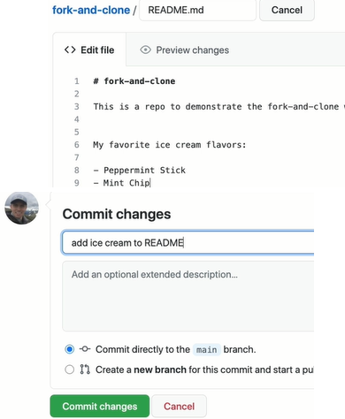

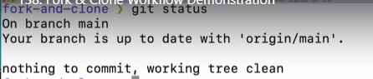

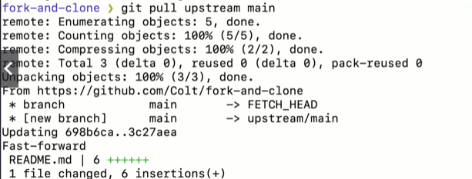
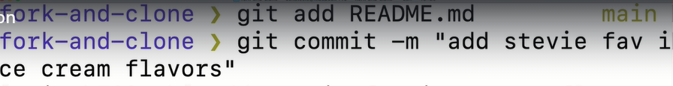
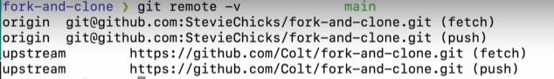
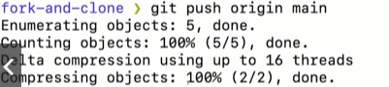

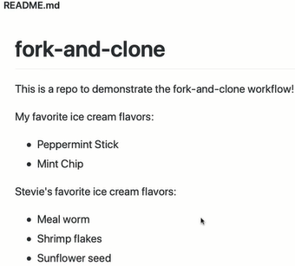
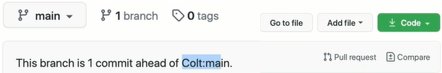

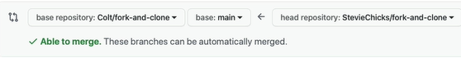
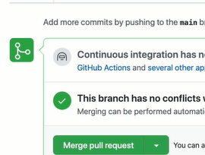

Use git pull to stay up to date with others work.

Rebasing : The Git Scariest Command
When colt first learn git he was told to avoid rebasing if possible.
Rebasing is part of workflows or companies workflows on engineering teams.
Rebasing and merging, two ways of integrating changes from different branches.

Why is Rebasing Scary? Is it?
There’s a divide over the git community.
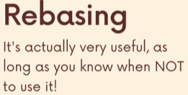

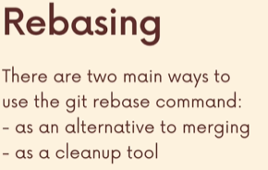

Comparing Merging & Rebasing
Lets discuss about the problem with merging or something Rebasing address that merging does not.
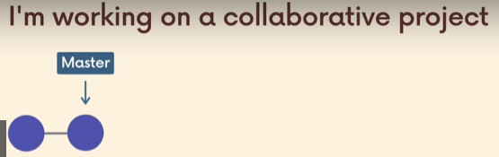
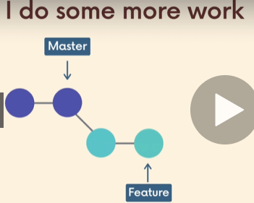

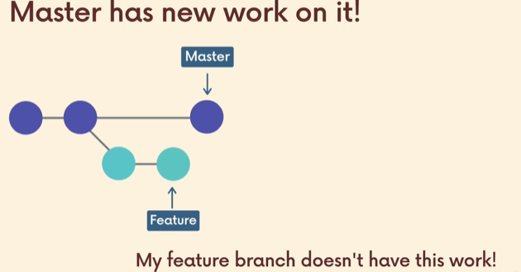
Lets say a fellow coworker did a bug fix and committed and the audit review merge the code, while i am still working and i have made couple of commits(checkpoints) in my working directory, i havent push anything or made a pull request.
I proabably want that new work in my feature branch. Maybe there’s a bug fix or something. I dont wanna diverge from master branch for super long time without getting those new changes.
So how do i get that work from the master to my feature branch.
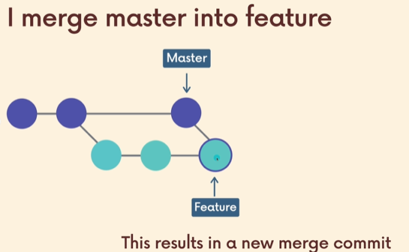

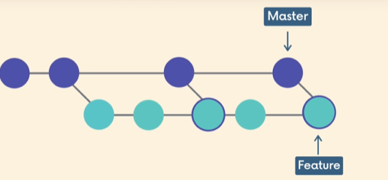

after we are sync with master branch, we continue our work. We see the next day, there is more work from coworker, our feature is behind of master by ‘x’ commits.
As i continue to work, so instead of 5 commits on my feature branch i have whole bunch of commits on my feature branch. Maybe i am working over the course of weaks. The rest of the team is very active. Lots of changes happening at the meantime.
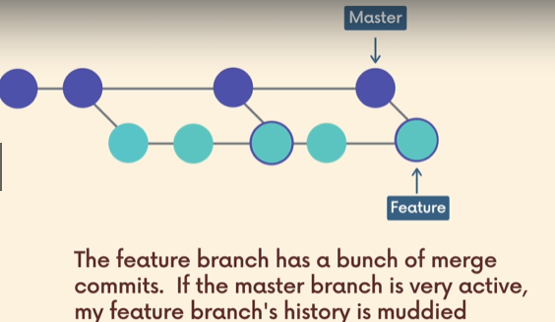

So my entire feature branch has dozen of merge commits, that dont say anything about what i am working on, they have nothing to do with my actual code or commit. They just have to be there bcoz i merge.
Just like me, its happening to others too.
If everyone else has merge changes into their origin/master. They need to get those changes into their feature branches.
So everyone feature branches might be riddled with bunch of merge commits.
When after fixing when they merge into origin/master, there is just bunch of useless merge commits as part of the history.
Not useless, but not informative. That makes our history muddier.
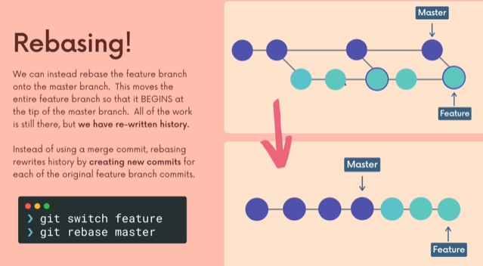
We still have the 3 commits on feature branch and 4 commits on master branch.
It has been re-written, it doesnt indicate the time when things were made. Each commit has data so that is preserved. The commits are moved around in order to give us this new structure.
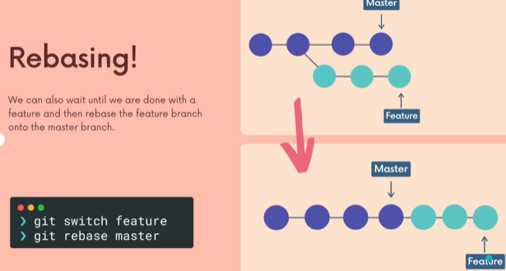

Its a linear,focused structure, easily readable that these are the commits i have done with my branch and the changes i made vs having merge commits * 10 ppl working on it just like us.

Rebase Demp Pt 1: Setup & Merging
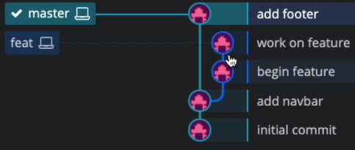

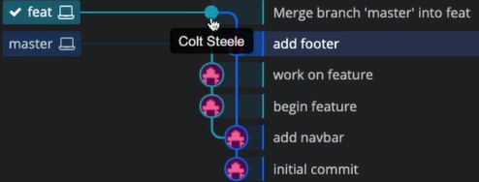

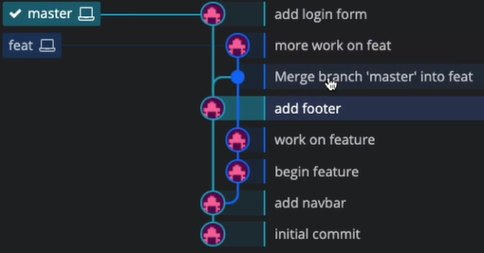

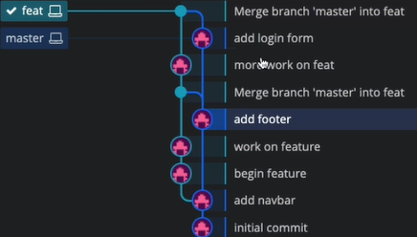
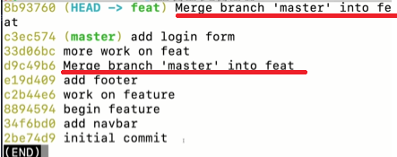

The commit history is harder to follow.
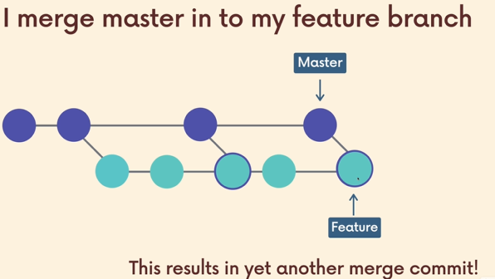

For a large project with just 100ppls with lots of commits, it would be way easier if we have a clean commit history. Where the commits are group together in a logical way and you minimize the no of those merge commits.

Rebasing Demo Pt2 : Actually Rebasing
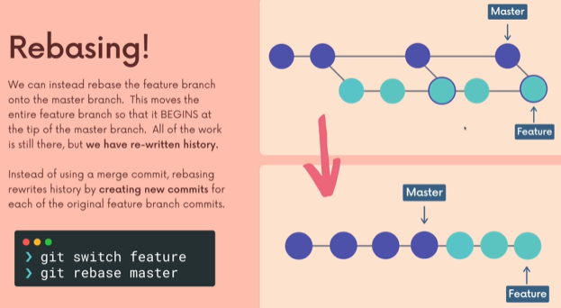

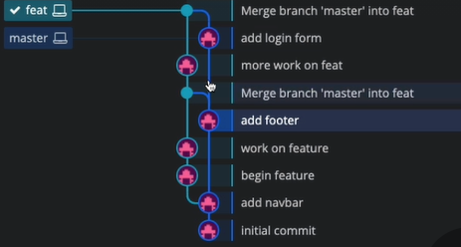

for Feat Branch, Above, i have twice merged in changes from master.
So the master branch doesnt have any of my feature stuff. I dont wanna merge anything directly into master rn. Instead, i am just concerned of getting the changes of my coworkers that are constantly adding to master.
Pull request are merged in. That gives me merge commits.
So, instead i am going to rebase. When we use the git rebase command. We are rewriting the history.
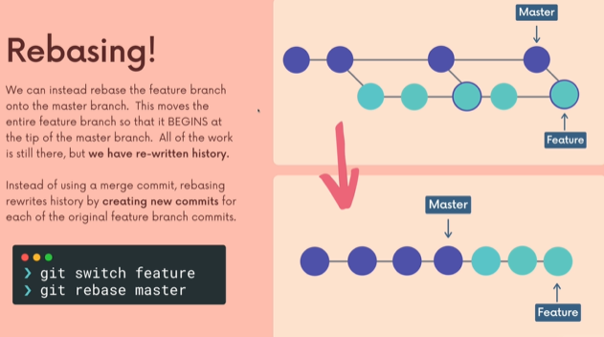
The merges are removed

Above is the actual history, when we use rebase the history get switch around a bit. Infact we get new commits generated.
Instead of writing merge commits for us, when we use git rebase, it rewrites history and creates brand new history for each of the original feature branch commits.

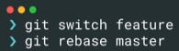
So this is not gonna screw up the master branch. Instead its gonna rewrite history by taking my feature branch commits and taking new ones that are based on the original and putting it at the tip of the master branch. Rebasing them at the tip of the master.
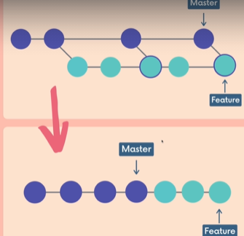
How many commits on my feature branch, the work is not gonna be destroyed. But the commits are going to re-created and they are gonna be add to the tip of the master branch.
We ended up with a linear structure.

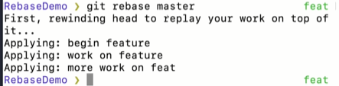

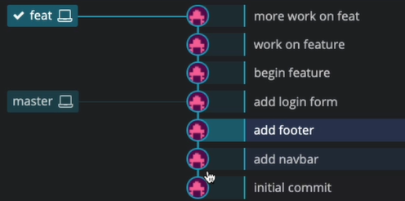

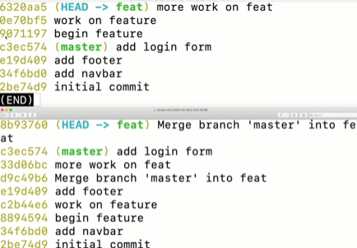
We see the commit hash is changed, but the commit message are still the same and the metadata.
This tell us its not update to commit history. Its new history.

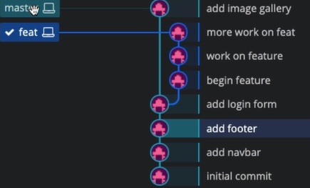

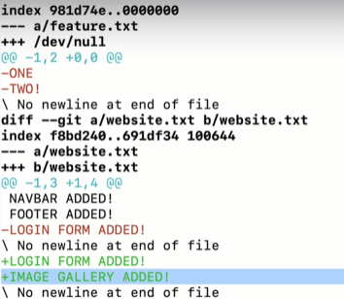

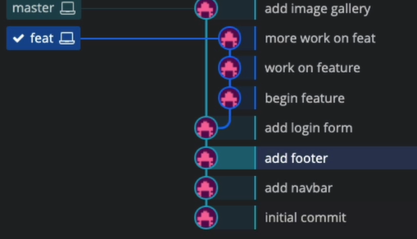

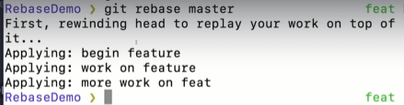

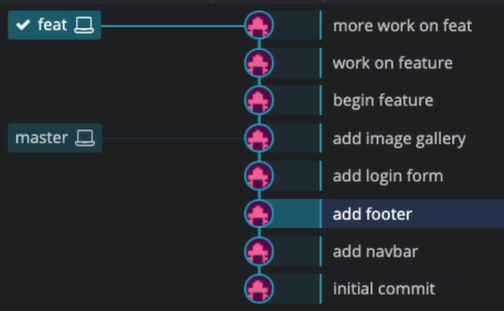

We not rebasing the master branch.
We are rebasing onto master branch.
So our feature branch commits are recreated, and all begins at the tip of the master and we end up with this nice linear structure.

The Golden Rule: When Not to Rebase
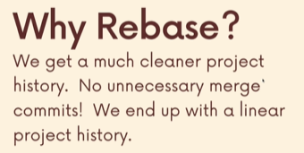

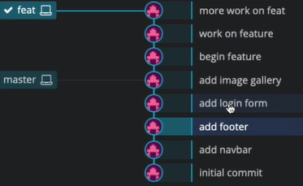

Why rebase instead of merge?
Its very clear what work a specific person did. So it doesn’t matter bunch of 10 and 100 other commits on master branch, that they happen simultaneously over the course of development.
My feature branch commits are all located together at the tip. This makes it easier to for someone to review my commits and take a look at the code base and try to read whats going on.
In open source projects, with thousand of contributors and tons of work all the time. This makes it easier for some random person to go read the history, go try and understand what did this feature do.
Rebase makes total sense by kazim.
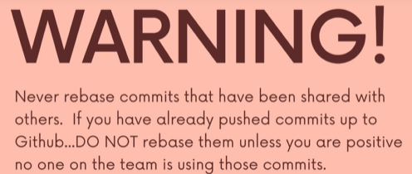



You only rebase commits that you only have in your machine and other people don’t.
So your feature branches that you’re working on, you don’t want to rebase the master branch because people presumably have that master branch or the main branch they have the commits that you have.
So if you rewrite those commits and they’re totally new, thats a problem when you try and push up.
So you work on a feature branch, whatever you’re doing in there, fixing a bug, adding a new feature, etc.
You can rebase your work from that branch onto the master branch or onto another branch. You not changing the master branch. You don’t change the branch that you are rebasing onto.
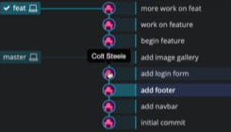
We didn’t change the master branch, we only change the feature branch.
The branch that you are on when you call rebase is the one that is being rebased.
Goldren rule when not to:
So once you push the feature branch upm if somebody has pulled that down, if they have that history. If they working on it, then you don’t wanna rebase.
Your company will tell you, if you are collaborating with people, you’re rewriting history using rebase. If you don’t know how to properly rebase that can be a big problem. If you are working at a company, they are going to make it very clear to you what the workflow is. And if they expect you to rebase everything or to never rebase and only or rebase in X situtions.
Dont rebase shared history and any commits ppl already have only rebase stuff that is yours and yours alone.

Handling Conflicts and Rebasing
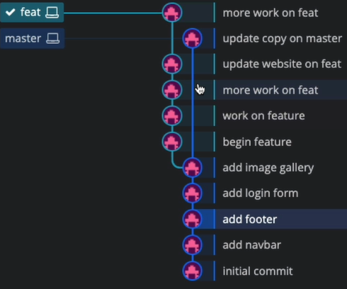

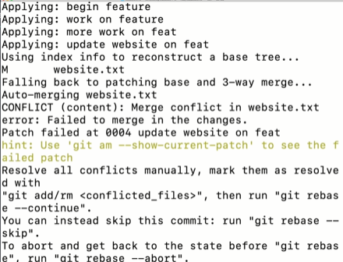

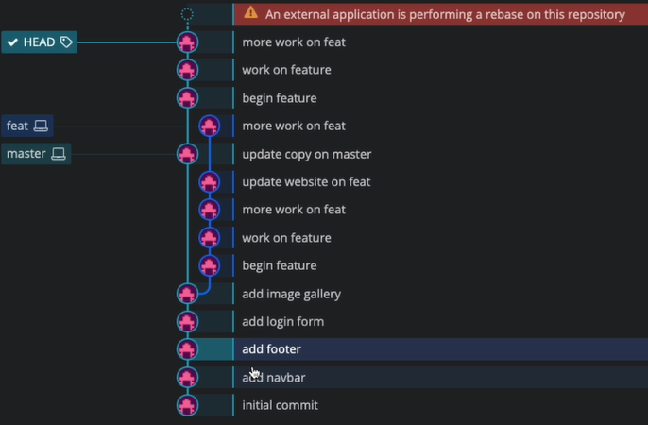

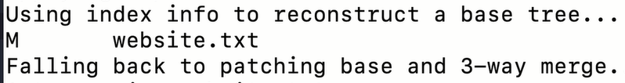

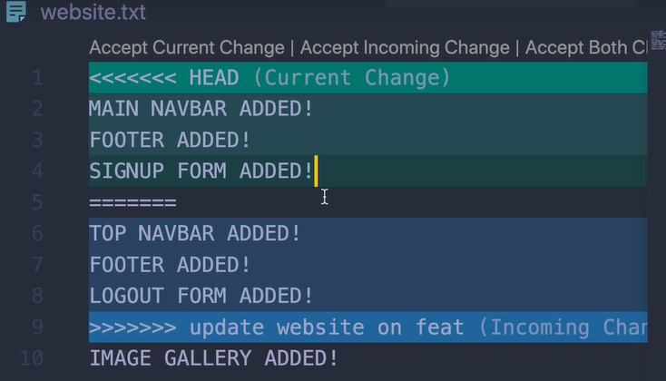

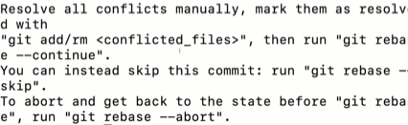

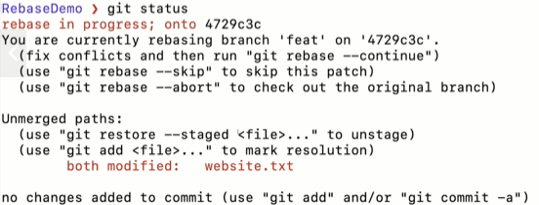

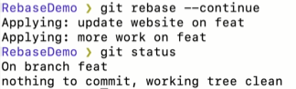

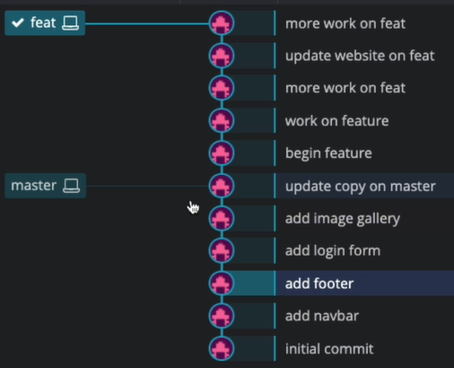

Cleaning up History with interactive rebase
We use it to clean up our git history. Basically to go back and rewrite commits.
Not just the previous commits but 10,50 far away.
We can rewrite commits, you can edit commits, we can do something called fixing up and squashing commits. We can even drop commits entirely.
Its fun to go back and edit history.
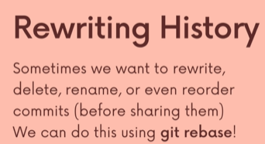

Rewrite history, edit commits, can change/edit commits n commit msgs.
We can change the contents of a commit. We can drop or delete an entire commit.
We can even re-order thing using git rebase.



We don’t wanna rewrite history on shared files. We don’t wanna rewrite commits and make new commit hashes and screw everything up, if collaborators already have the work.
This is a common workflow, if you’ve been working on a branch. You have lots of commits on a feature you’ve been working on for a while. You kind have some half baked commits. Or some buggie thing or half complete commits.
If you want to go through and streamline that and combine commits down, rename them, that could be a nice thing to do b4 you share that code with anyone.
So its a step a lot of ppl take before, sort fo grand unveiling of their branch of their feature.
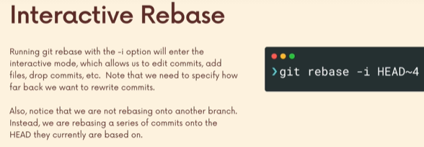
We use the git rebase cmd, typically we don’t specify a branch to rebase onto.
Instead we just gonna rebase series of commits onto the head we currently based on.
So we gonna rebase myfeature where it currently is, I.e my feature.
Its just a way of recreating commits, every commit that we specify and we do have to provide a range. How far do we wanna go back. Recreate each one.
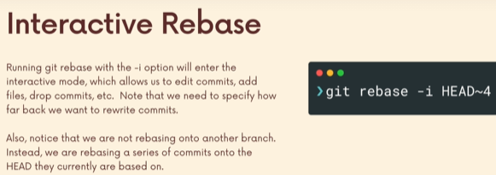
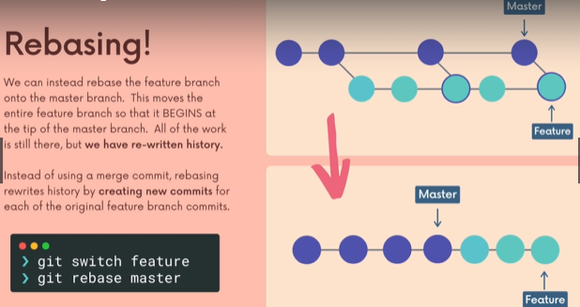

it went through all the commits on feature branch and it recreated it each one at the tip of the branch. Each new commits has a new hash, but it still have the same contents ,the same commit message . But they are distinct commits.
Using the interactive mode, is as you make a new commit, change the name or drop it.Dont make a new version of this one.
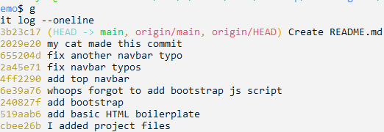

You wanna rename the commit msg before you share that with somebody. Often when you doing some work locally on some project. You working on your own, you not paying attention to commit message guidelines.
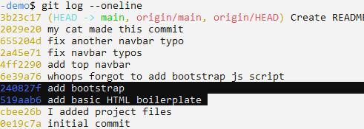

I wanna combine that into one commit.
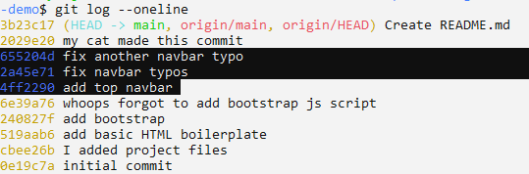

Also I wanna drop the comit “my cat made this commit”
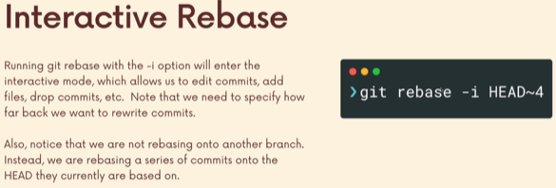
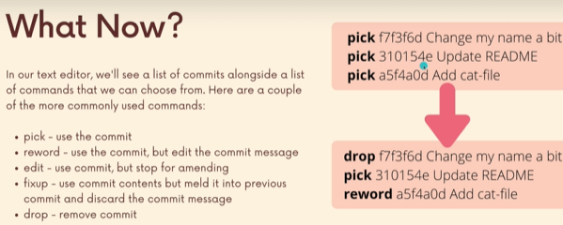
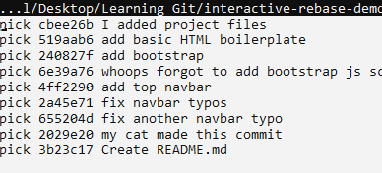

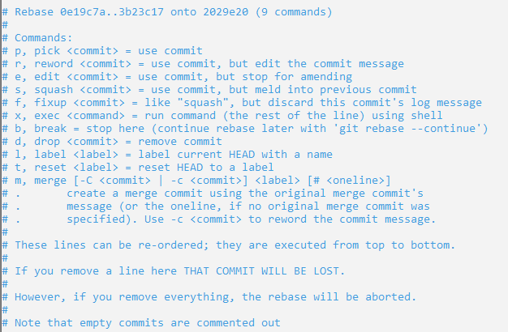

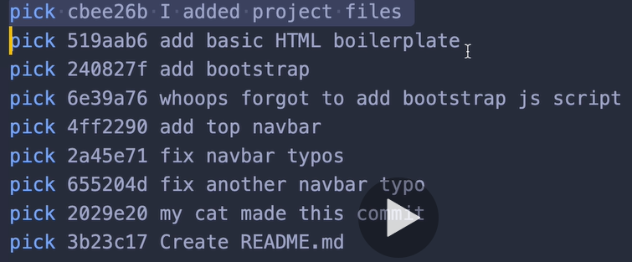

Notice that the order is reversed and we don’t see the “initial commit”
Basically we running pick command on all the commits.
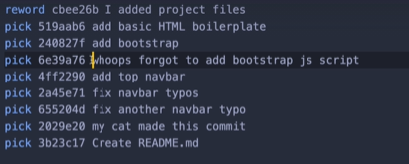
Then save.

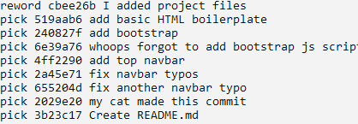

Save and close the editor.

Then, editor will open to write new commit message.
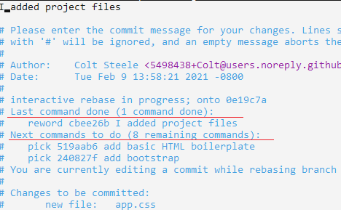

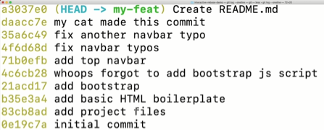
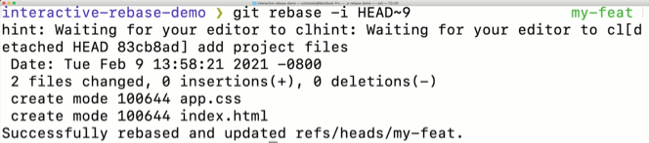

By rewording, all commit is changed starting from the commit which is changed.
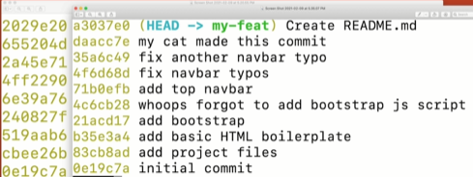

Fixing and Squashing Commits with interactive Rebase

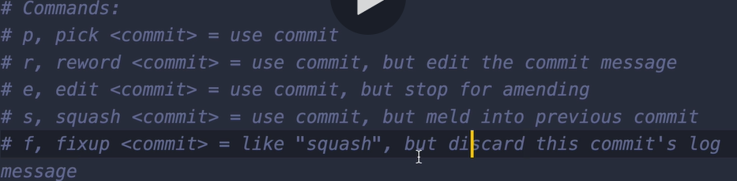
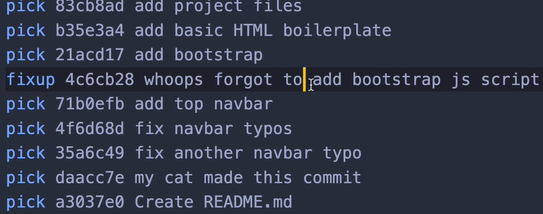

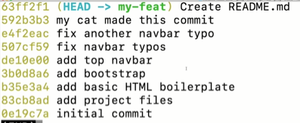

Everything from where the changes made to the freshest change all hashes are change.
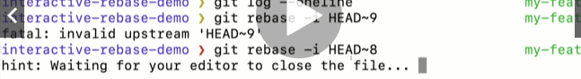
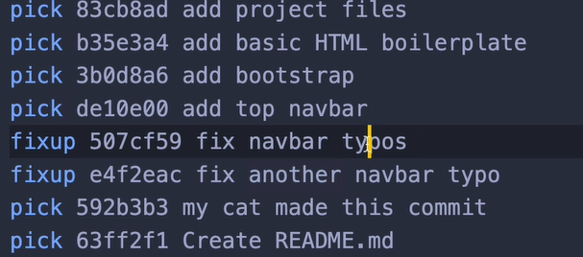

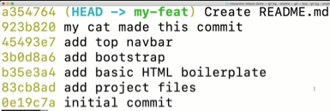

Dropping Commits with Interactive Rebase
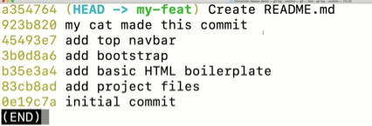

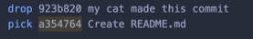
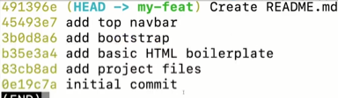

The commit disappeared with its contents.
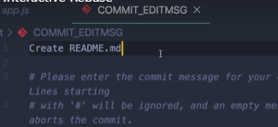

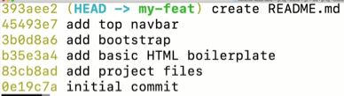

Git Tags: Marking important moments in histories
Most often tags are used to mark different releases, different versions or projects.

The Idea behind Git Tag


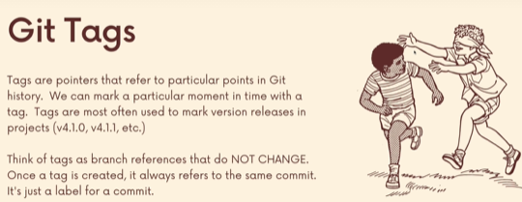

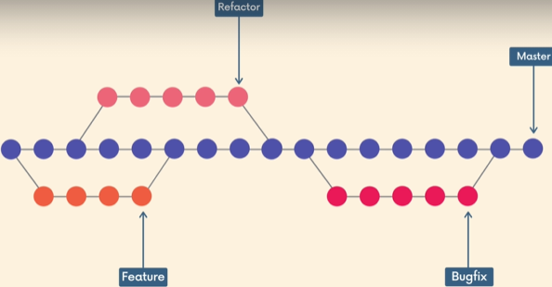

Think of as a sticky note on commits.

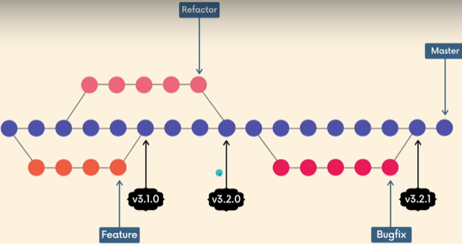

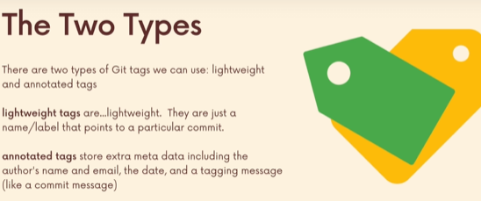

Annotated Tags are generally preferred in a lot of big projects. They will ask you to use annotated Tags and not lightweighted Tags.

Semantic Versioning
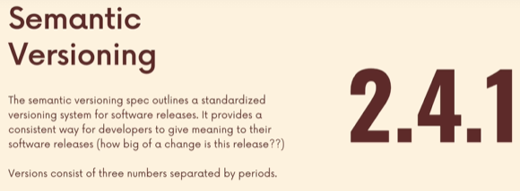

The most of common use case of tags is versioning and marking release point for for some piece of software.
Semantic Versioning is a protocol,set of rules,requirements that dictate how version number is assigned and incremented.

Semantic Versioning:
The idea is just to layout set of rules for making versioning transparent and consistent meaningful. So that these release number as meaning encoded in those three digits.
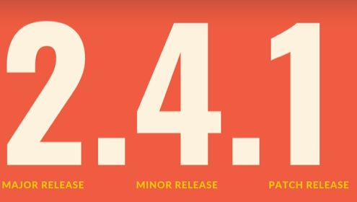




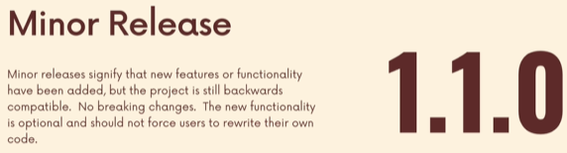
Whenever there is a minor release you need to reset the patch number back to zero.

It makes it clear to any users or consumers of some piece of software, how significant a change is, in a new version.
Which is very important when you relying on some piece of software or library as dependencies for your own software you building.

Viewing & Searching Tags
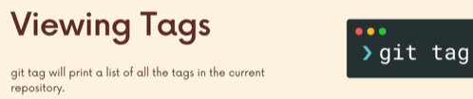

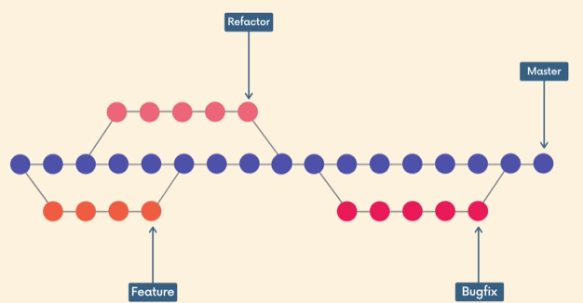
Static reference.

Concept of tag is to mark or highlight some point in history, have that as a static reference. Not move it until we explicitly want it to move it.

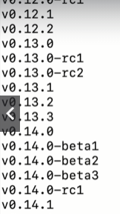
Each refer to a particular point in time, commit.

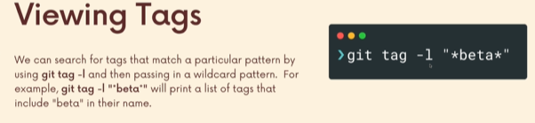
-l is implicit
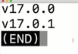

Comparing Tags With Git Diff
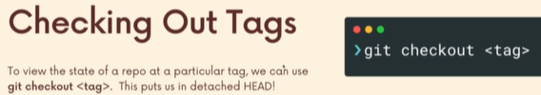

Tag is referring to a particular commit not a branch.
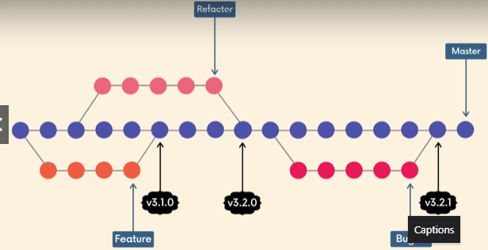

When we gonna checkout a tag, we will be at detached head.

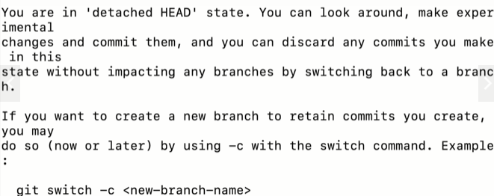

Creating Lightweight Tags
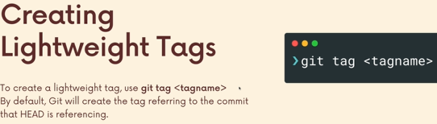

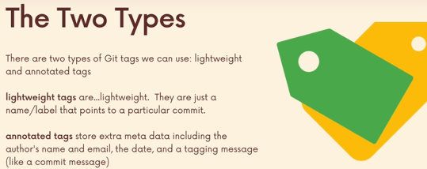

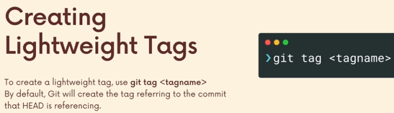

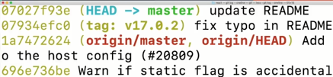

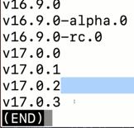

Annotated Tags

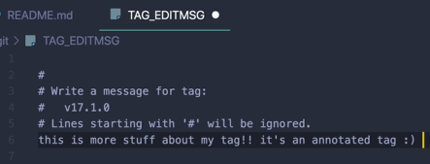
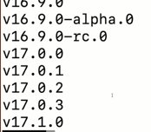

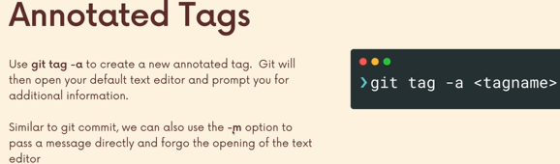


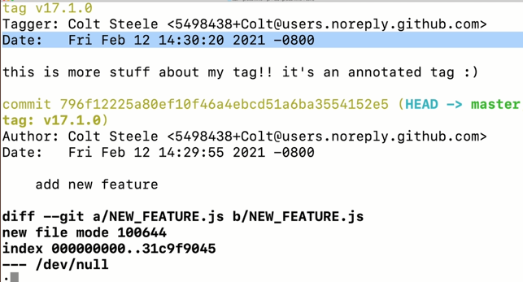
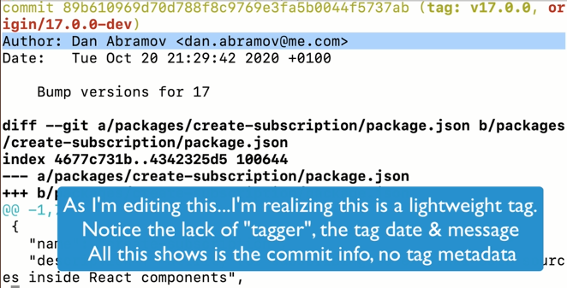

Tagging Previous Commits
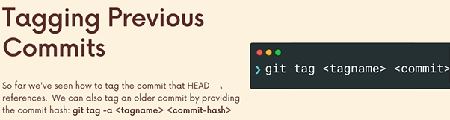


Replacing Tags With Force
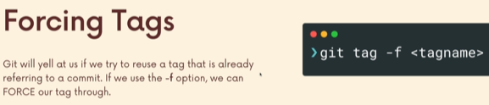
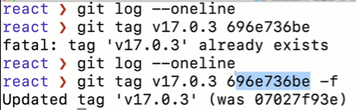

Deleting Tags
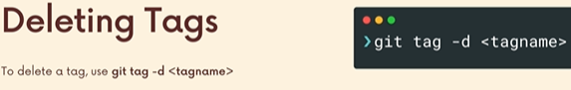
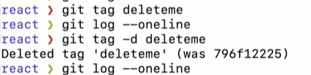

IMPORTANT: Pushing Tags
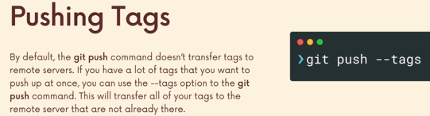

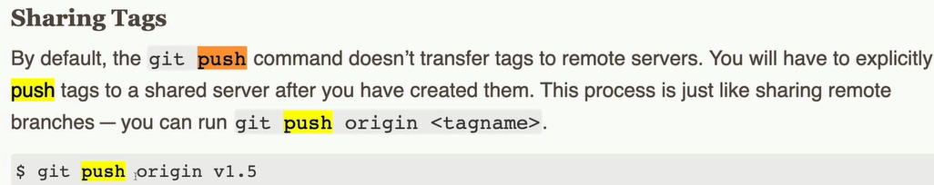
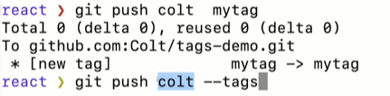
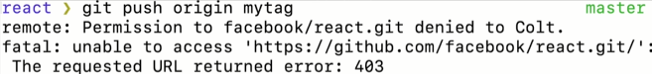

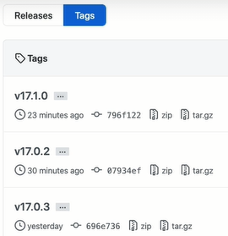

Git Behind the Scenes : Hashing and Objects

Working with the local file
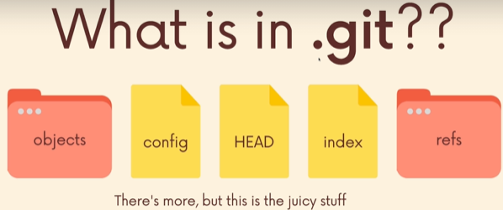

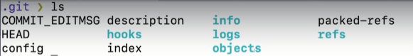
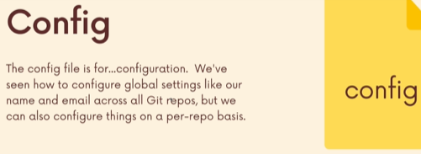

With git, there are multiple locations, from where we can configure settings. We can do it globally.
We can do system wide , globally.
Or local per repository basis.
So in every repositroy > .git > .config.
Anything u do in this folder will be local to this repository.

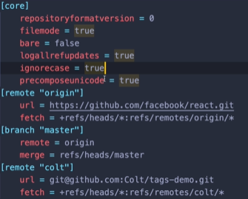

In this folder you add git aliases.
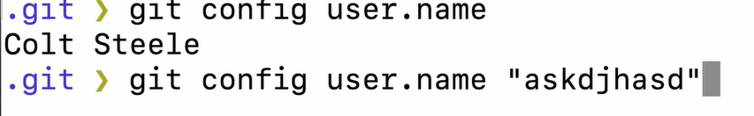

When I do the above, I do it globally.
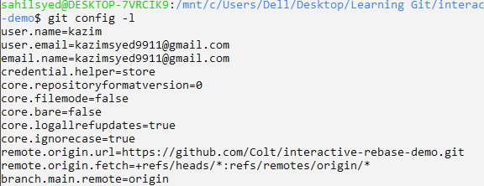
Check out the git-scm.com documentation.
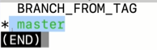
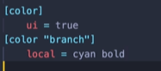
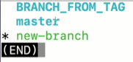

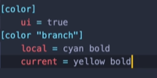
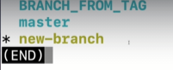

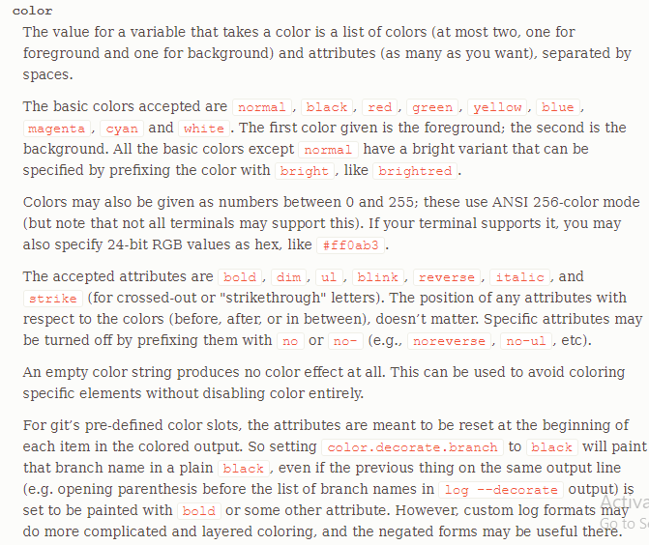

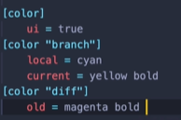
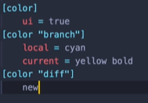

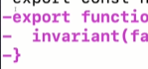

You can change text editor locally for this repo.

Inside Git: The Refs Directory
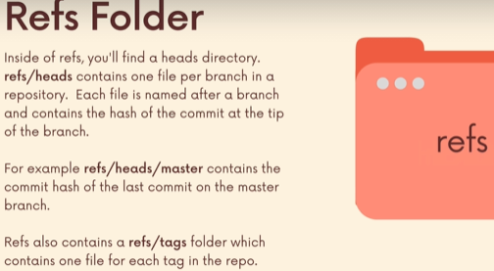

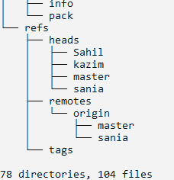
refs for references.
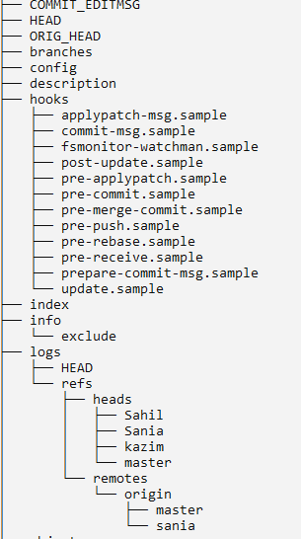

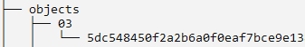
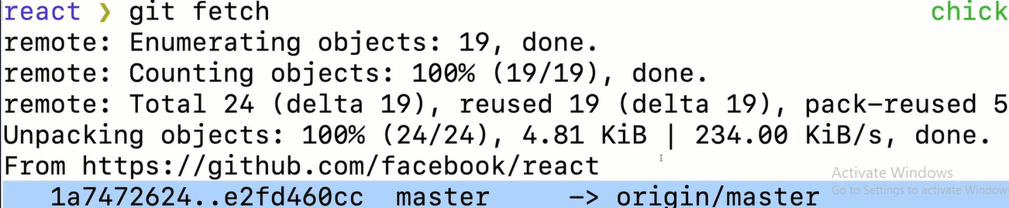

Inside Git: The Head file
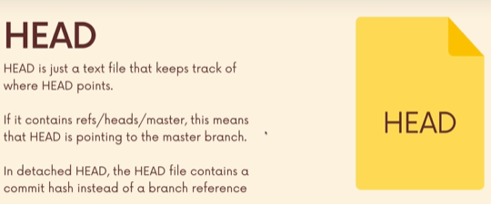

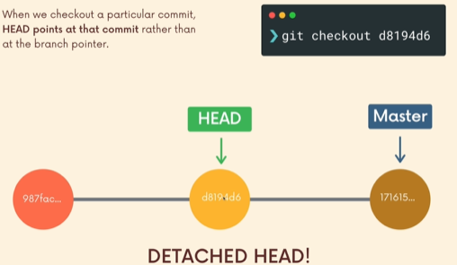
There is a difference between Head and Heads

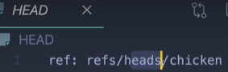
This is, where we at.

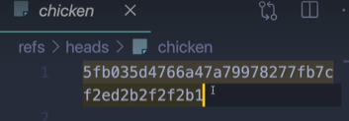
Head always point to the newest commit on a branch. Else we at detached head.

Inside Git: The Objects Folder
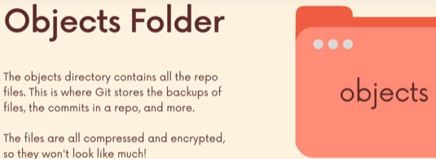

Git store full snapshot, it doesnt store diffs.


A Crash Course on Hashing Functions
Hexadecimal character, exactly 40 digits long.
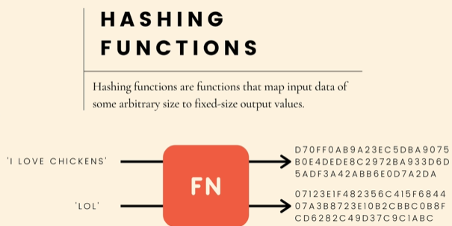

Hashing functions are family of functions that have one goal. They take input of arbitary size and spit out output of fixed size.
The input can be a sentence,3 characters, files or single number.
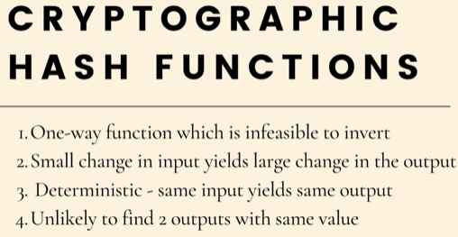

Cryptographic hash functions which is a subset of hash functions, they do the same thing, they map the data of arbitary size to an output of fixed size.
Use: info security, digital signatures, cryptocurrency , git.
Deterministic, that “I love chickens” hash should always be the same. There should be consistency.
It should be a one way function, that is by knowing the output you cant be able to infer,guess or reverse engineer the output. So if i were to implement a password login authentication for a user on a website. We use hashing func to store hash
output of a password. So if somebody get access to our database, they see the password hashes.
Also a small change in input yields large change in the output.
Unlikely to find 2 outputs with the same value.
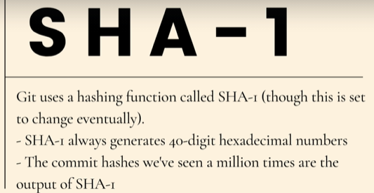

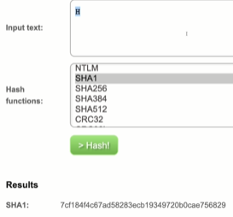

Git As A Key-Value Datastore


Git use SHA-1 for above.
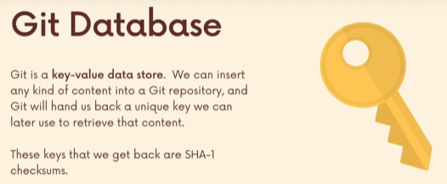

Outside dmart, they take ur stuff and give u a key or token.
Git is gonna give us a unique key which we gonna use to retrieve the content.

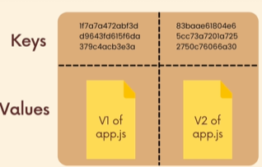
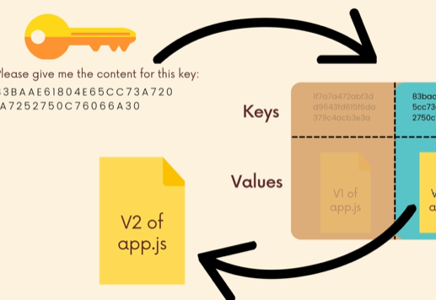

Hashing with Git Hash-Objects
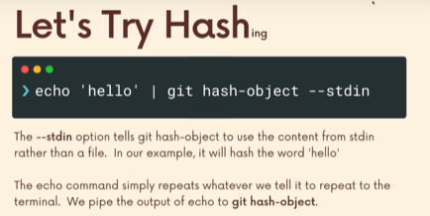

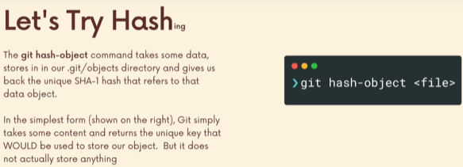
It takes content from a file and it returns a unique SHA-1 hash that would be use to store our objects.
When we store something, git will create an entry in objects directory.
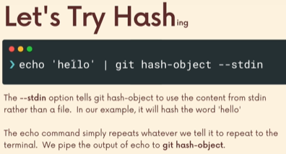

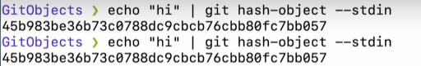

Just like i can run git init anywhere i can also run git hash.
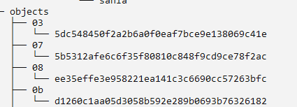

Note: Objects isnt changing at all, its just saying hello git, if u were to store anything what will be the hash.
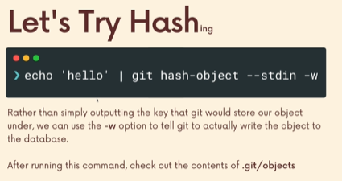

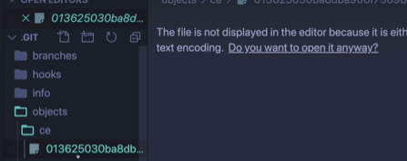

Retrieving data with git Cat-File

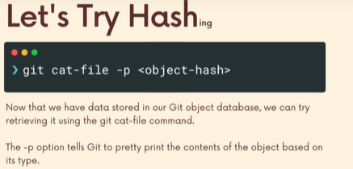

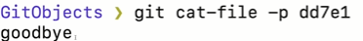

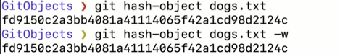

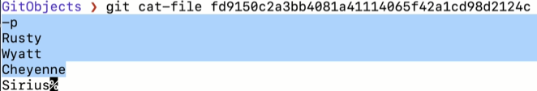
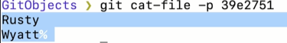

FYI, the dog.txt file was never committed.
We see git store two different version of file.
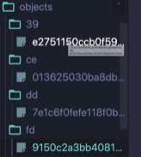

Deep dive Into Git Objects: Books
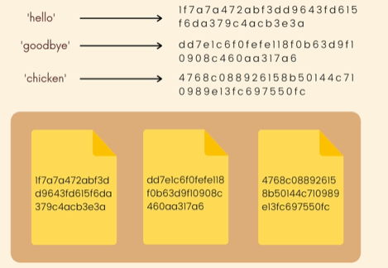

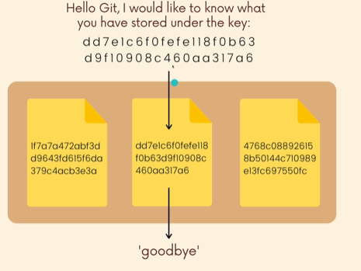

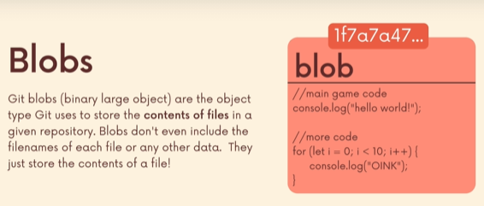
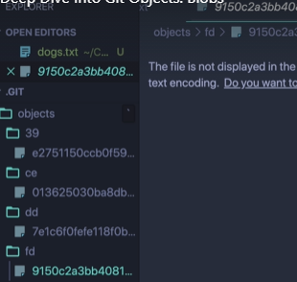
They all are blobs.

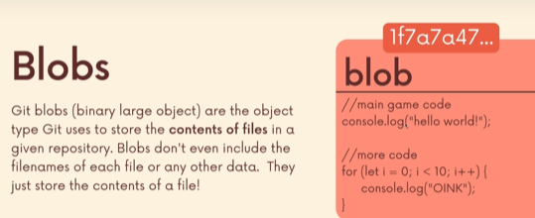

Git stores the content of a file, seperate from the main. Each blob get its own hash.
Blobs is the building block, the way we use git of different files, different contents ,different versions, different commits.
Blobs does get its own hash, its not a commit hash. It looks like commit hash cuz similar Hash func outputs.

Deep dive Into Git Objects: Trees
In a large project with 100 files, with nested folders. If i tell git to checkout this branch or commit. It can change all of those files,folders ; it can delete some in my working directory. It might add whole bunch of stuff.
How is it able to keep track of that structure.
Its not just the insides of the files, its the relationships between the files. Its the structure of directories.
Blobs store the contents of the files.
Trees stores the content of the directories.
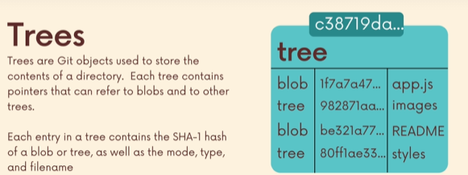
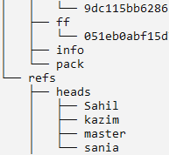
Above we have references to blob and trees.
Remember: The BLOB only stores the content referenced by a tree using some hash based on its contents. The tree maps file-names/folder to hashes.

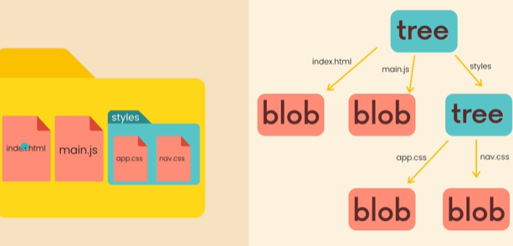

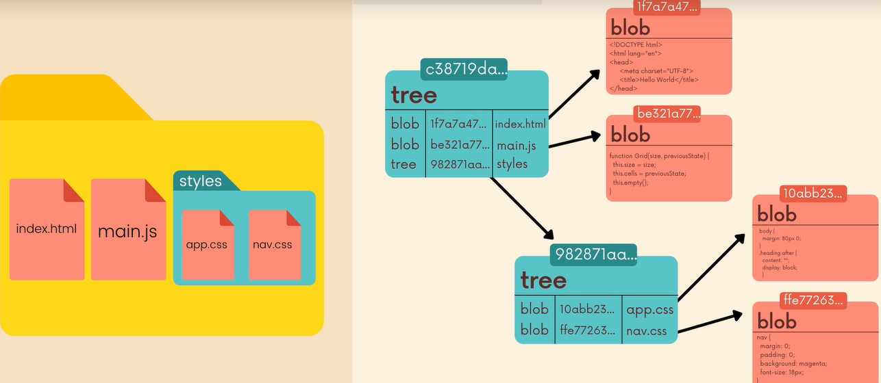

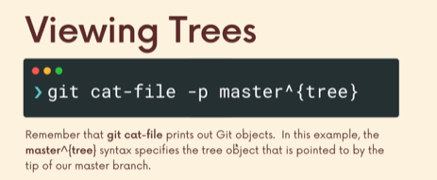

In an existing repository that has history we can view trees.
Master^{tree} is a particular way to refer to the tree object that is pointed to by the tip of our master branch.
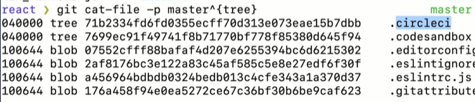
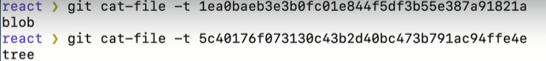

Deep Dive Into Git Objects: Commits
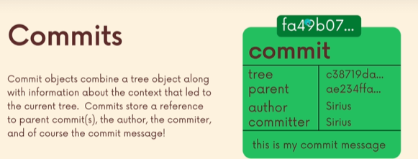
When we make a commit, git generates a new commit git object.
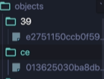
First two digits make a folder, inside that 38 digits remaining that is the name of the encrypted binary compressed files.

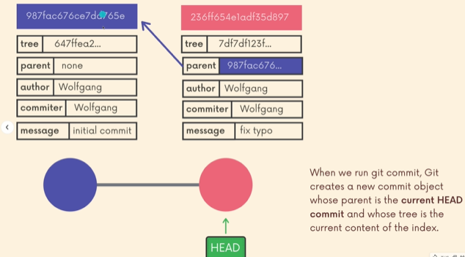

Also, the tree that it stores in this commit, the tree is the current content of this index, the staging area.
So there’s an actual index file.
Basically, everything that we have worked on all along, the changes we have staged. When we run git commit, a tree is generated. That tree reflects the content of the index that is included in the commit.

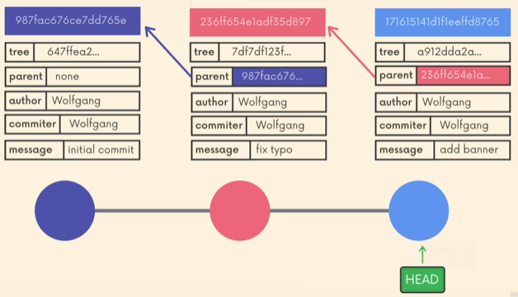
Every commit is tied to a tree, that tree represents the structure of application i.e. other trees or blobs(which contains the content identified by a hash).
So if we checkout a commit, git is gonna use that tree and use it as the basis for our working directory.
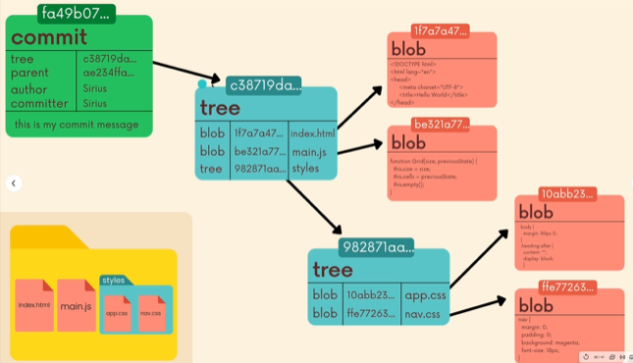
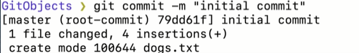
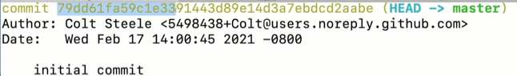
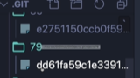

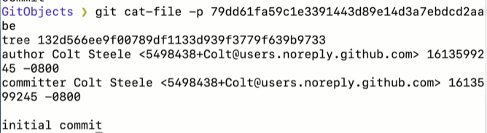
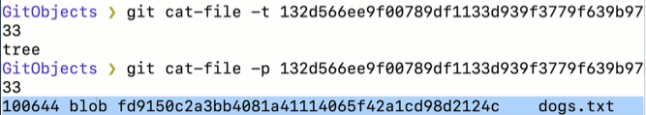
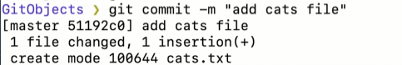

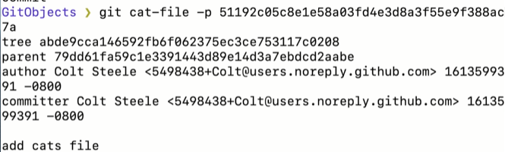

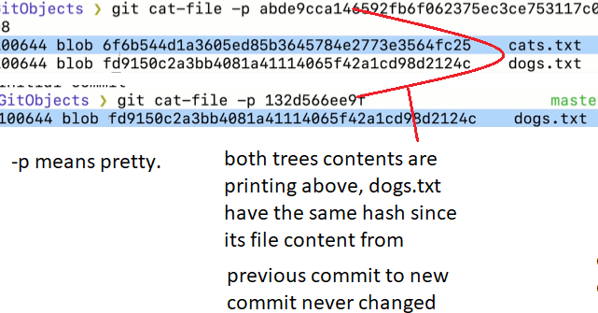
If i changed the contents of dogs.txt and commit, new hash will be created for dogs.txt.
Recap:
Every commit has a reference to a parent unless its the first commit.
Every commit has a tree thats a index that showcase the content of a directory.
i.e. references to other trees(files and folders) and blobs(file contents).
Everything gets hashed (blobs,trees,commits) and git uses this hashes to easily determine something is changed. Also uses the hashes as primary key to pick out file content.
When i switch branches, its gonna look at tip of the branch, whats that commit and whats the tree in that commit and restore the files in the working directory based on the state of the tree.
Annotated tag store a reference to a commit.

The Power of Reflogs, Retrieving Lost Work
Reflogs is used when u screw something terribly or when i lost a commit or when i rebase when i shouldnt have rebase. When i want to undo something that seems undoable. With the help of git reflog often we can fix things, we can dig ourselves from pretty bad situations.

Introducing Reflogs
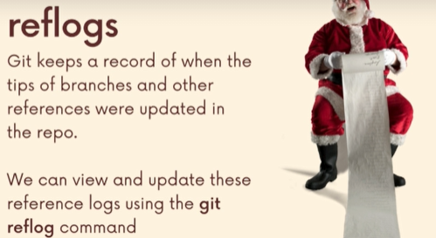

Reflog is short for reference logs.
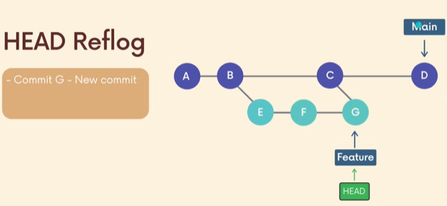

Every branch has branch reference, that is what keeps the tip of the branch.

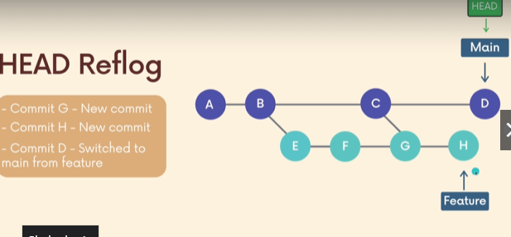

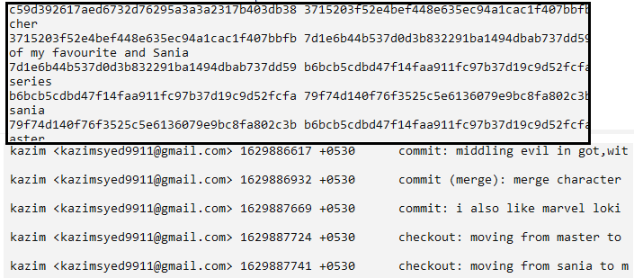
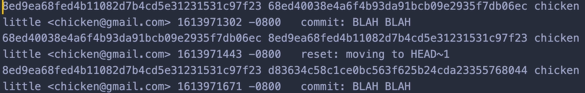
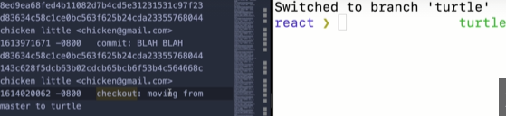

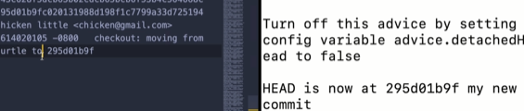

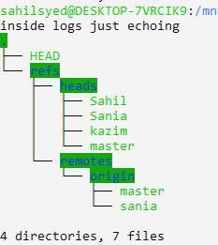

The Limitations of Reflogs
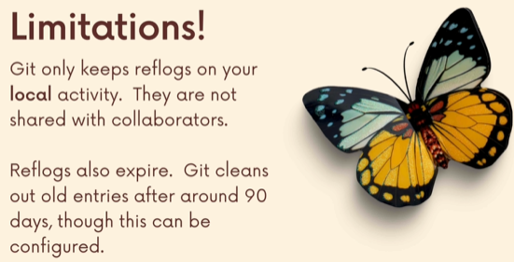

The Git Reflog Show command
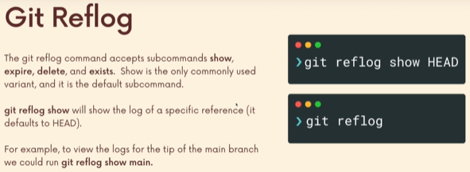
Git reflog show HEAD/branchtip/remotebranch.

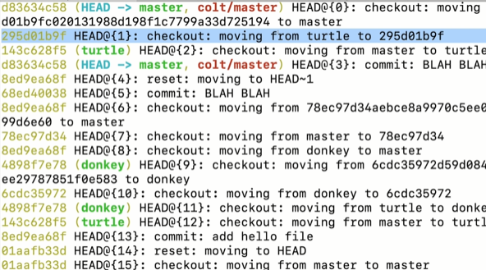

We see a log ,similar to git log.
It includes checkout to a branch.
Also this going to be history of things, we could delete commits, we could rebase. We still gonna see entries from when we did that.
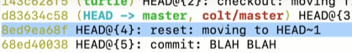

Colt made mistakes and use reset to correct. He recorded the video couple of times.
You see, HE still have that hash.
But in git log, that hash is completely gone, Cuz he reset.
This history is only for 90 days.
Whereas git log will show me
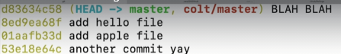

history from one commit to another commit.
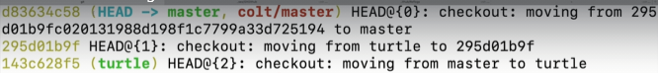
You can read, he moved from detached head to master.
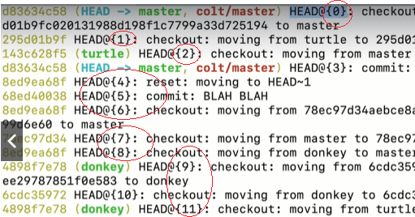

The most recent starts from Zero.

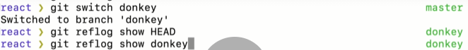

Passing Reflog References Around
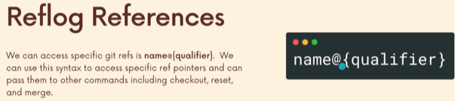
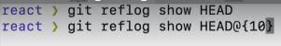

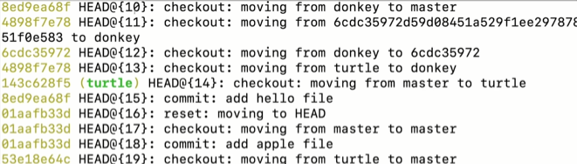

Head~ is used for going backwards. i.e. two commits away from head
two entries ago from head.
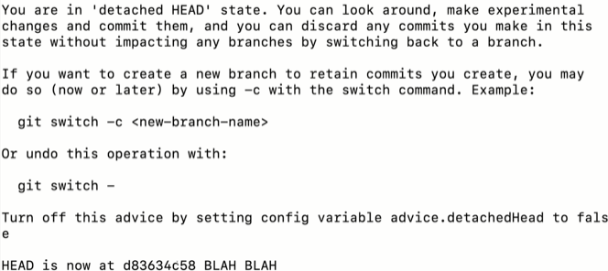



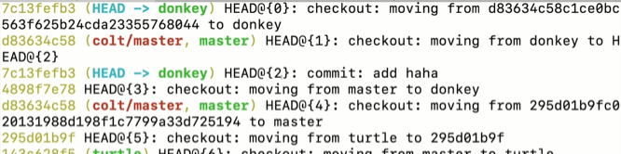
it only show changes that matters.
It wont show that i run
git log –oneline

Time-Based Reflog Quantifiers
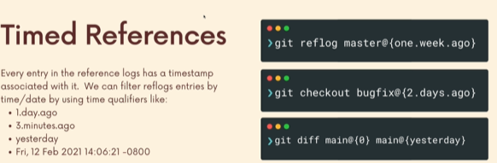
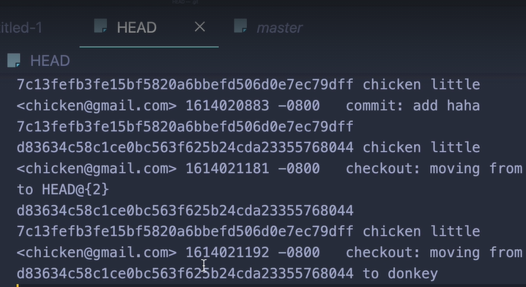
Every entry has a commit hash, the user who made it, timestamp.

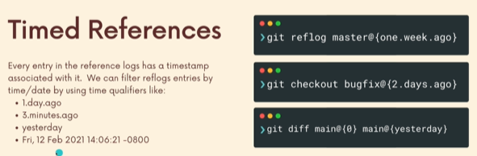
We can see how the master branch look like yesterday, diff between today and yesterday work.



Lets say uk things were working one week ago, so
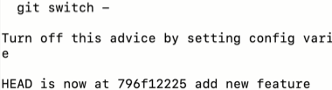

Rescuing Lost Commits with Reflogs
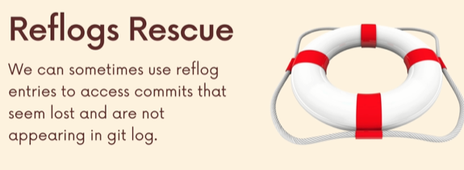
So, we can do hard reset and lose commits and still retrieve the data from reflogs.
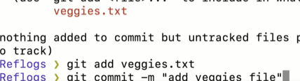

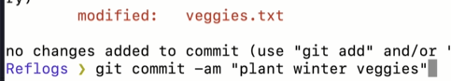

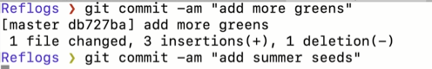


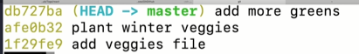

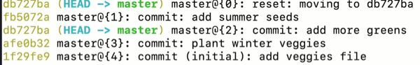
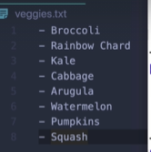
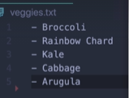

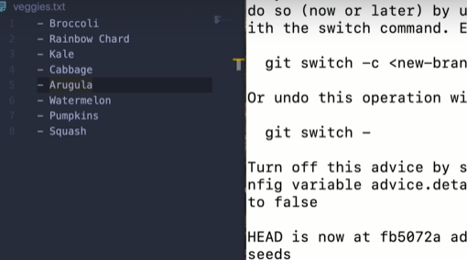
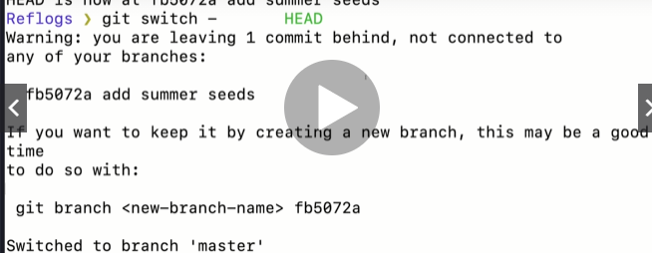

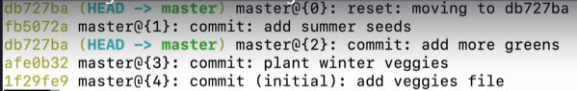
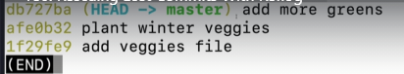

Even though “add summer seed” is long gone we can still find it reflogs.
Every so often git will go and remove commits that are dangling, that arent actually connected.
“add summer see” doesnt have a parent, child.
Since we have reflogs we can go and restore it.
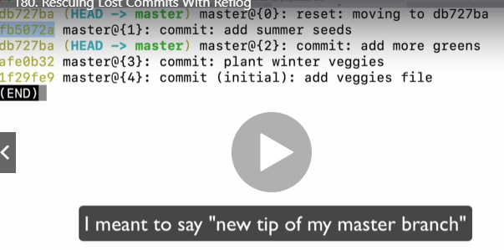



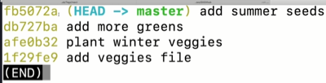

We just undid a hard reset, keep in mind it only works on local changes.

Undoing A Rebase w/ Reflogs : - Its a miracle

Rebase rewrites commits and make new commits and those old ones are gone.
Thats what we used to know so far.
Heres the kicker.
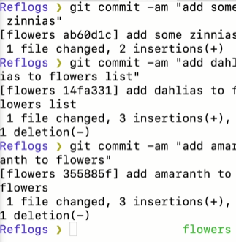

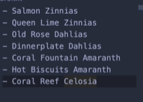

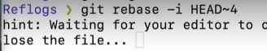

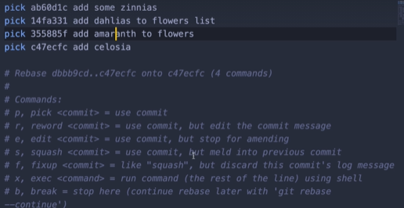
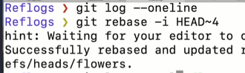

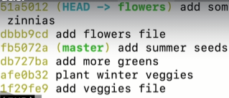
I can repeat the process one more time.

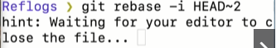

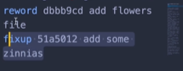
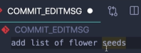

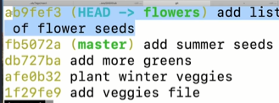

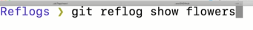
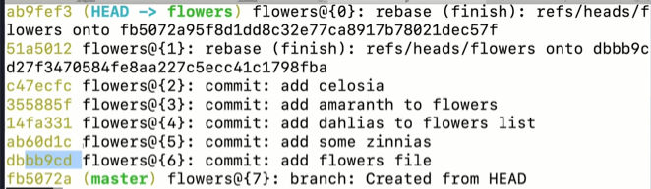
Lets say i want to go to the below highlighted commit
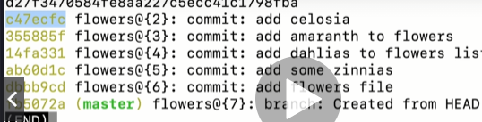

So i can have all of the prior commits.
I can use the hash or flowers@{2}.
The commit is still stored in .git directory in the objects directory. It wont be there forever. Git goes through it periodically and it cleans up some of this as garbage collection. If it notices objects that are not reachable.

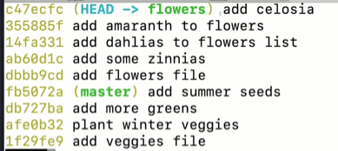

The reason this work, every commit inside the file has its parent commit.

I CAN UNDO THE UNDOING BY GOING TO REFLOGS
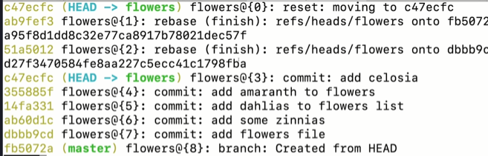

Writing Custom git aliases
How to define aliases and put into global config file.

The Global Git Config File
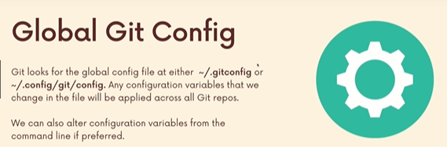
There is a local config file in every single git repo.
So setting in there, apply to one- repository.
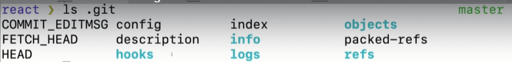
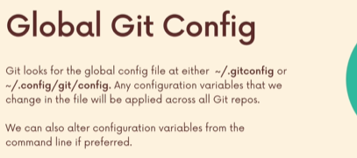

Here, we can config settings that apply to all repository.
There is a one level above that, that is system wide. If u have multiple user accounts on one machine. That system wide will apply to all users.
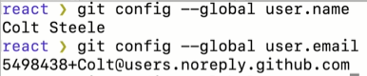


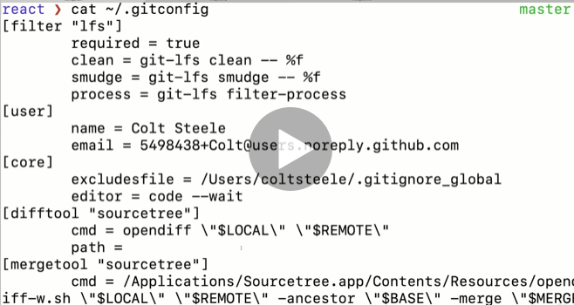
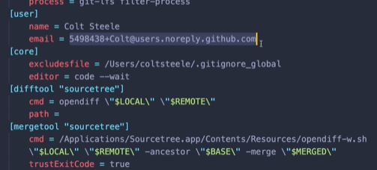

This did the same exact thing if i do this.

Writing our First Git alias
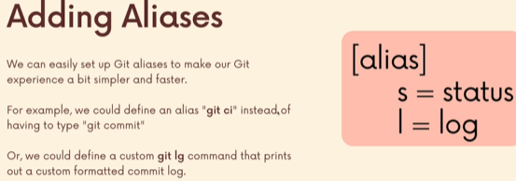

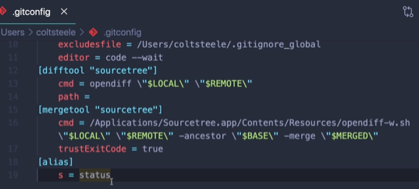

Only status.
We still need to run git s.
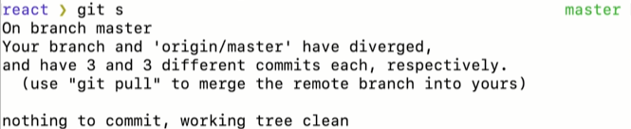

Setting Aliases From the Command Line
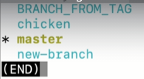

Aliases with Arguments
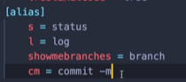

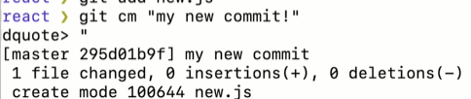

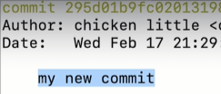

Exploring Existing useful Aliases
Links:
Ultimate Git Alias Setup
must have git alias advance example
Git Alias Github Repo
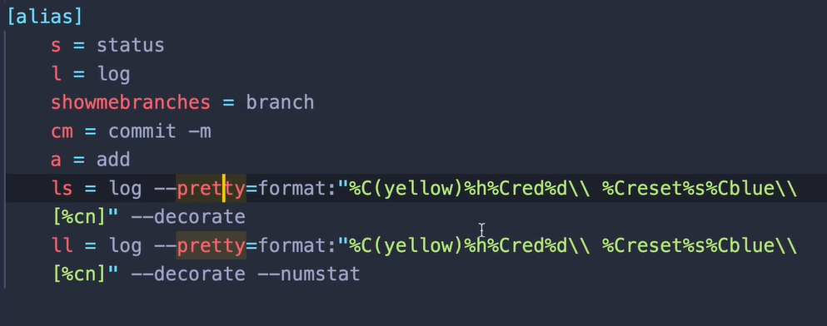

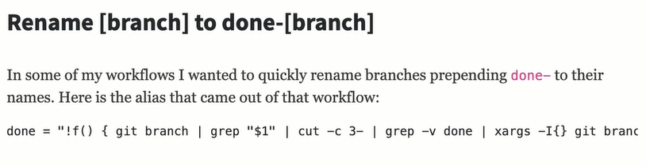
Last one is pretty good.

